**A**

**PROJECT REPORT**

**ON**

**A STUDY ON CUSTOMER SATISFACTION ON**

**A**

**ELECTRIC VEHICLE ON BLIVE EV STORE, JALGAON**

**FOR**

**SUBMITTED TO**

**KAVAYITRI BAHINABAI CHAUDHARI NORTH MAHARASHTRA UNIVERSITY, JALGAON**

**IN PARTIAL FULFILLMENT OF TWO YEARS OF FULL- TIME DEGREES MASTERIN BUSINESS ADMINISTRATION**

**SUBMITTED BY**

**Mr. Harshal Suresh Sonawane.**

**MBA (Marketing)**

(Batch-2022-2024)

**UNDER THE GUIDANCE OF**

**Prof.Dr Yogesh Patil Sir**



# KCE Society's Institute of Management and Research Jalgon

**MASTER OF BUSINESS**

**ADMINISTRATION**

**CERTIFICATE**

**This is to certify that Mr Harshal Suresh Sonawane student of Master of Business Administration of the KCES’s Institute of Management and Research, Jalgaon has completed project work on the topic of a study of consumer satisfaction at blive ev store under the guidance of Dr. yogesh patil**

**He has completed this project work in fulfillment of the requirement for Master of Business Administration of the KBC North Maharashtra University, Jalgaon for the academic year of 2023 - 2024.**

**We wish him all the success in his future endeavors.**

**Dr. Yogesh patil Dr. Parag Narkhede Dr. Mamata Dahad Prof. B.V. Pawar**

**Project Guide MBA Coordinator Hod Director**

**External Examiner 1 External Examiner**

**DECLARATION**

|**Harshal Suresh Sonawane** have completed the summer internship project the report entitled "**A Study on Customer Satisfaction on Electric Vehicle" Level at EV Blieve** **store**, Jalgaon (Two-wheeler) under the guidance of

**Dr.Yogesh Patil**

In the fulfillment of Master in Business Administration to **Kavayitri Bahinabai Chaudhari North Maharashtra University, Jalgaon.**

This is an original piece of work and I have neither copied nor submitted it earlier elsewhere

Harshal Suresh Sonawane

MBA [MARKETING]

Seat No: 838384

**ACKNOWLEDGMENT**

express my sincere gratitude and appreciation to all those who have contributed to the successful completion of my Summer Internship Project, entitled **"A STUDY ON CUSTOMER SATISFACTION ON A ELECTRIC VEHICLE ON BLIVE EV STORE, JALGAON"** undertaken during the [2023-24] as part of my Masters of Business Administration (MBA) program at KCES’s Institute of Management and Research, Jalgaon.

I would like to extend my heartfelt thanks to Dr. Yogesh A. Patil, my project guide, for his/her invaluable guidance, mentorship, and unwavering support throughout the duration of the internship. His insights, constructive feedback, and encouragement significantly enriched my learning experience and helped shape the quality of this project.

I would also like to express gratitude to Dr. Parag Narkhede, MBA Coordinator, and Prof. Mamata Dahad, Head of Management Department and Prof. Dr. B.V. Pawar, Director for the encouragement and support provided throughout the internship period.

I am also thankful to Mrs. Anita Sonawane of Blive Ev Store, for providing me with the necessary resources, exposure, and a conducive environment to carry out my internship. Her willingness to share knowledge and expertise has been instrumental in enhancing my understanding of the practical aspects of business administration,

I appreciate the cooperation and assistance received from all those who directly or indirectly contributed to the successful completion of this project. Their support has been invaluable in shaping my professional growth and enhancing my practical skills.

Lastly, I would like to express my heartfelt thanks to my family and friends for their continuous support, encouragement, and understanding throughout this internship journey.

Date:

Place: Jalgaon

Harshal Suresh Sonawane

(Exam Seat No.838384)

**INDEX**

|  |  |  |
| --- | --- | --- |
| **Sr. No** | **Topic** | **Page No.** |
| **1** | * **Executive summary** | **6** |
| **2** | * **Introduction of project** * **Introduction** * **Profile of the blive ev store** * **Theoretical background** | **7-23** |
| **3** | * **Research methodology** | **24-26** |
| **4** | * **Data analysis and**   **interpretation** | **27-37** |
| **5** | * **Summary of Findings** * **Conclusion** | **38-39** |
| **6** | * **Suggestions And Recommendations:** | **40** |
|  | * **bibliography** | **41** |
|  | * **annexures** | **42-44** |

**EXACUTIVE SUMMARY**

BLive isn't exactly a showroom for their own brand of electric vehicles. Instead, it's a multi-brand EV experience store. This means they offer a variety of electric two-wheelers from different manufacturers, all under one roof.

Here's a quick rundown of BLive EV:

Concept: One-stop shop for electric vehicles (EVs) in India.

Products: Electric scooters and bikes from various brands including Kinetic Green, Ampere, BattRE, Detel, Felidae, Gemopai, Techo Electra, and more.

Services:

Ability to explore and compare different electric two-wheeler options.

Purchase electric scooters and bikes.

Purchase EV accessories like chargers and batteries.

Financing options may be available.

While I couldn't find any BLive showrooms specifically in Pune, there is one in Aurangabad, Maharashtra. This showroom is open from 10:00 am to 7:00 pm daily. You can find their contact information on their website [BLive EV Store Multi-Brand Electric Scooter Experience Center (Myra EV Store)].

* 1. **INTRODUCTION**

In today's dynamic market landscape, understanding consumer satisfaction is paramount for businesses striving to thrive a midst fierce competition. This study delves into the realm of consumer satisfaction within the context of blive evs, a leading entity in Jalgaon's market. Blive evs, renowned for its innovative products and exemplary services, stands at the forefront of consumer-centricity, aiming to exceed expectations and foster enduring relationships with its clientele.

As consumer preferences evolve and competition intensifies, the need to gauge and respond to consumer satisfaction becomes increasingly vital. This study aims to unravel the intricate nuances of consumer satisfaction at blive evs, delving into factors such as product quality, service efficiency, brand perception, and post-purchase support. By scrutinizing these facets, we seek to uncover insights that will not only bolster blive ev's competitive edge but also cultivate a deeper understanding of consumer behavior in the local market.

Through rigorous analysis and insights garnered from this study, we aim to provide invaluable recommendations for blive evs to enhance its offerings and fortify its relationship with its clientele. By identifying areas of strength and opportunities for improvement, this research endeavor aspires to contribute to blive evs continuous quest for excellence and customer eccentricity.

This introduction sets the stage for an in-depth exploration of consumer satisfaction dynamics at blive evs, shedding light on critical factors influencing consumer behavior and loyalty in the Jalgaon market. Through empirical research and strategic insights, this study endeavors to illuminate pathways for blive evs to not only meet but exceed consumer expectations, ensuring sustained success and prosperity in the dynamic business landscape of Jalgaon.

* 1. **PROFILE OF THE BLIVE EV STORE**

**ELECTRIC TWO-WHEELER S AND THEIR ROLE IN INDIA**

Electric two-wheeler s, like electric bicycles and electric scooters, are gaining popularity due to their eco-friendly and cost-effectiveness. They use rechargeable batteries to power electric motors, offering a quiet and smooth ride while reducing emissions compared to traditional gasoline-powered vehicles. Many cities are promoting their use to combat air pollution and reduce traffic congestion**.**

**ROLE OF ELECTRIC TWO-WHEELER**

**Sustainable Transportation**: With the growing concern over air pollution and carbon emissions, E2Ws offer a cleaner alternative to traditional petrol-powered two-wheeler s, contributing to India's efforts towards sustainable transportation.

**Urban Mobility:** In densely populated cities like India's metros, E2Ws provide a practical solution to navigate through traffic congestion, offering a quicker and more maneuverable mode of transport compared to cars.

**Affordable Transportation:** Many E2W models are cost-effective in terms of both purchase price and running costs, making them accessible to a wider segment of the population, including students and lower-income individuals.

**Last-Mile Connectivity:** E2Ws are often used for last-mile connectivity, bridging the gap between public transportation hubs and final destinations. This is particularly useful in areas where public transport infrastructure is limited.

**ELECTRIC VEHICLE GROWTH**

Electric two-wheeler s have experienced significant growth in recent years due to various factors such as increasing environmental awareness, government incentives, technological advancements, and changing consumer preferences. This growth is expected to continue as more people seek eco-friendly and cost-effective transportation options. Additionally, improvements in battery technology are making electric two-wheeler s more practical and appealing to a broader audience. As a result, many companies are investing in electric two-wheeler development, and the market is becoming increasingly competitive.

**1.3 OWNER AND PROMPOTERS**

**Actually there are four owners of blive ev store**

|  |  |
| --- | --- |
| **Name of the person** | **Nature of the office** |
| **Mrs Anita sonawane** | **Owner** |
| **Mr Rushikesh dhuppad** | **Owner** |
| **Mr Uday patil** | **Owner** |
| **Mrs Neha patel** | **Owner** |

* 1. **VISION MISSION AND QUALITY POLICY**
* **Mission** The mission of Blive EV Store regarding electric two-wheeler s is to accelerate the transition to sustainable transportation by offering high-quality electric scooters and bikes that are accessible, reliable, and innovative. They aim to empower individuals to make Eco-conscious choices by providing a range of electric vehicles that are not only environmentally friendly but also convenient and enjoyable to ride. Blive EV Store is committed to promoting the widespread adoption of electric two-wheeler s as a means to reduce carbon emissions, alleviate urban congestion, and create a cleaner, healthier future for communities worldwide.
* **Vision**: Blive EV Store envisions a future where electric two-wheeler s are the norm, providing eco-friendly, efficient, and stylish transportation solutions for urban and suburban commuters. They aim to revolutionize the mobility sector by offering a diverse range of electric scooters and bikes that are affordable, technologically advanced, and seamlessly integrated into people's daily lives. Blive EV Store strives to contribute to a cleaner environment and reduce carbon emissions by promoting the adoption of electric vehicles as a sustainable alternative to traditional gasoline-powered transportation.
* **Quality** **policy**: The quality policy of Blive EV Store regarding electric 2-wheelers focuses on delivering products that meet or exceed customer expectations in terms of performance, reliability, and safety. Blive EV Store is committed to:
* 1] Ensuring the highest standards of quality in the design, manufacturing, and testing of electric two-wheeler s.
* 2] Continuous improvement of processes and technologies to enhance product performance and durability.
* 3] Compliance with all applicable regulations and industry standards to guarantee the safety and satisfaction of customers.

By adhering to these principles, Blive EV Store aims to establish itself as a trusted provider of premium electric two-wheeler s and maintain customer satisfaction and loyalty.

* 1. **PRODUSTS AND SERVICES**

BLive is a one-stop multi-brand platform for all the EV related solutions. We’ve created a vast ecosystem, bringing the entire electric vehicle universe under one roof. As a multi-brand EV hub, we offer a wide range of premium EV brands in various categories for customers to buy.

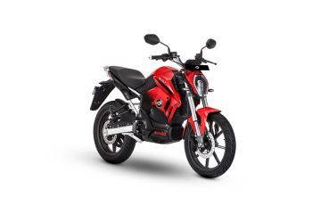**REVOULT RV 400**

SPECIFICATION:

RANGE:15O KM/CHARGE

TOP SPEED: 85 KMPHPOWER:3000 W

CHARGING TIME :4 HR 5 MIN

WHEEL TYPE:ALLOY

TECHOMETER: DIGITOL

PRICE:1.69 LAKH

**EVTric Rise**

**SPECIFICATION**

RANGE:100 KM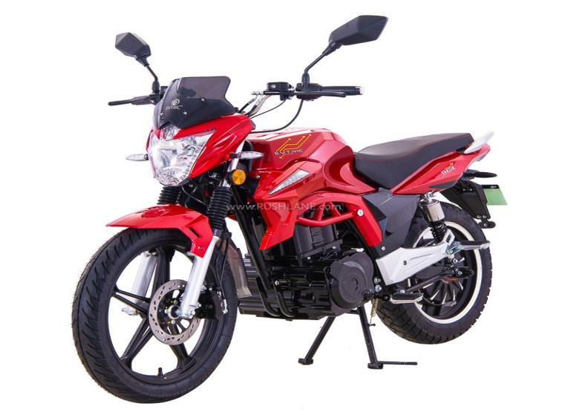/CHARGE

TOP SPEED:70 KMPH

POWER:2400W

CHARGING TIME:4 HOUR 30 MIN

WHEEL TYPE:ALLOY

TECHOMETER:DIGITOL

PRICE:1.11 LAKH

**EVTric Ride**

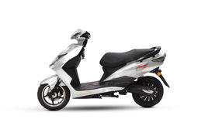**SPECIFICATION**

RANGE:75 KM/CHARGE

TOP SPEED:25 KMPH

POWER:250W

CHARGINGTIME:3HOUR

WHEEL TYPE:ALLOY

TECHOMETER:DIGITOL

PRICE:71000

**EVTric Connect**

**SPECIFICATION**

RANGE:106KM/CHARGE

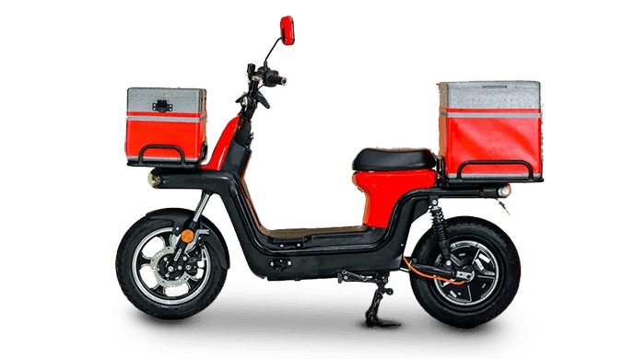TOP SPEED:55 KMPH

POWER:1200W

CHARGING TIME:4 HOUR 5 MIN

WHEEL TYPE:ALLOY

TECHOMETER:DIGITOL

PRICE:79000

**GEMOPAI ASTRID lite**

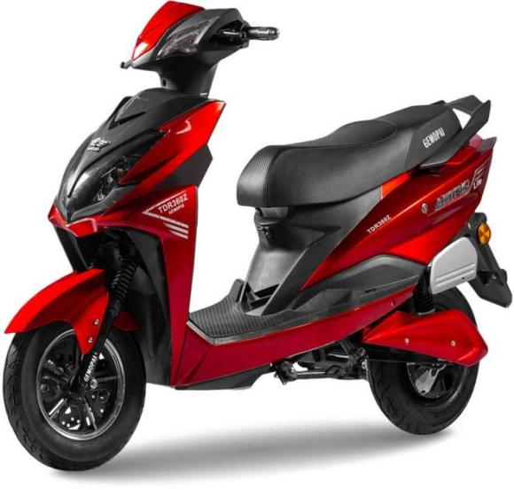**SPECIFICATION**

RANGE:90 KM/CHARGE

TOP SPEED:65 KMPH

POWER:2400W

CHARGING TIME:5 HOUR

WHEEL TYPE:ALLOY

TECHOMETER:DIGITOL

PRICE:83439

**GEMOPAI RYDER**

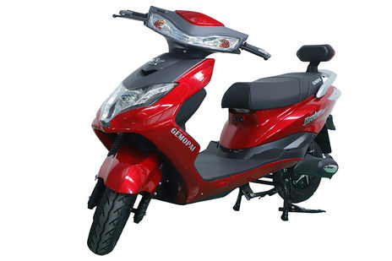**SPECIFICATION**

RANGE:90KM/CHARGE

TOP SPEED:25 KMPH

POWER:250W

CHARGING TIME:4 HOUR

WHEEL TYPE:ALLOY

TECHOMETER:DIGITOL

PRICE:73897-87927

* 1. **INFRASTRUCTURE FACILITIES**

Blive EV electric showrooms are equipped with modern infrastructure facilities to provide customers with a seamless and immersive experience. These facilities may include:

* Display Area: A spacious and well-lit showroom area where customers can explore a wide range of electric two-wheeler s, including scooters and bikes, showcasing various models, colors, and features.
* Charging Stations: Dedicated charging stations within the showroom premises where customers can charge their electric vehicles or test the charging capabilities of different models.
* Customer Lounge: A comfortable seating area with amenities such as refreshments, Wi-Fi access, and informational materials where customers can relax, interact with sales representatives, and learn more about electric mobility options.
* Service Center: An on-site service center staffed by trained technicians equipped with specialized tools and equipment to provide maintenance, repairs, and servicing for electric two-wheeler s.
* Interactive Displays: Interactive displays, touchscreens, or multimedia presentations showcasing the features, specifications, and benefits of electric 2-wheelers to educate and engage customers effectively.
* Financing and Support Services: Assistance with financing options, insurance, warranty coverage, and other support services to help customers make informed purchasing decisions and ensure a smooth ownership experience.

Overall, Blive EV electric showrooms are designed to offer a comprehensive and customer-centrist environment that promotes awareness, adoption, and enjoyment of electric mobility solutions.

* 1. **COMPETITORS INFORMATION**
* SATPUDA AUTOMOBILE HERO MOTORCORP
* BAJAJ AUTO –PAGARIYA AUTO CENTRE, JALGAON
* SHRI DATTA TVS
* ASTER HONDA
* RAM HONDA
* PANKAJ TVS AUTO
* SOLITAIRE SUZUKI
* ROYEL ENFIELD SHOWROOM –USHA MOTERS
* KALPANA JAWA JALGAON
* YAMAHA MOTERS SHOWROOM SAIISH MOTERS
* SUNSHINE MOTORS
* A VESPA AND APRILIA DOSHI AUTOMOBILE
* KTM JALGAON
* SACHIN AUTOMOBILES
* VIDYUT POINTOKINAWA EV SHOWROOM
* AMPERE ELECTRIC SHOWROOM KALPANA MOTORS
* PURVA MOTORS AND POWER TECH
* OLA EXPERIENCE CENTRE-ELECTRIC SCOOTER SHOWROOM

These are some competitors of blive ev stores

**1.7 SWOT ANALYSIS**

* **STRENGTH:**The strength of BLive EV Store lies in its commitment to providing high-quality electric vehicles (E Vs) and related services. It likely offers a diverse range of EV options, along with charging infrastructure solutions and possibly even after-sales support, contributing to the overall growth and adoption of electric mobility. Additionally, if BLive EV Store has a strong brand reputation and customer satisfaction, it further reinforces its strength in the EV market.
* **WEAKNESS**: Some weaknesses of electric two-wheeler s include limited range compared to traditional gasoline-powered vehicles, longer charging times, limited availability of charging infrastructure in some areas, higher upfront costs due to the expense of batteries, and concerns about battery degradation over time. Additionally, there might be perceptions about the performance and reliability of electric two-wheeler s, although these are improving as technology advances.
* **OPPORTUNITY:** Growing market demand due to increasing environmental awareness and government initiatives promoting sustainable transportation.

Technological advancements leading to improved battery technology, longer ranges, faster charging times, and enhanced performance.

* **THREATS:** Competition from traditional gasoline-powered two-wheeler s, which still dominate many markets due to established infrastructure and lower upfront costs.

Uncertainty regarding government policies and incentives, which could impact the attractiveness of electric vehicles compared to conventional options.

**2.1 THEROTICAL BACKGROUND OF THE STUDY**

**INTRODUCTION OF CONSUMER SATISFACTION**

**DEFINATION:**Consumer satisfaction is a term used in business to gauge how happy customers are with a product, service, or overall experience with a company. It reflects how well a company meets or surpasses customer expectations.

Here are some key aspects of customer satisfaction:

**Meeting expectations:** This is a fundamental aspect. If a product performs as well as customers expect, it contributes to satisfaction.

**Exceeding expectations:** When a product or service goes beyond what customers expect, it leads to higher satisfaction.

**Customer experience:** This includes all the interactions a customer has with a business, from purchasing a product to using it and getting customer service. A positive experience contributes to satisfaction.

Companies place high importance on consumer satisfaction because it impacts their success in several ways:

**Customer retention:** Satisfied customers are more likely to keep buying from a business.

**MEANING:** Consumer satisfaction is all about how happy a customer is with a product, service, or the entire experience they have with a company. It basically gauges how well a business meets or even exceeds a customer's expectations.

* **MEASURING CUSTOMER SATISFACTION**
* Customer Grievances
* Customer Focus
* Customer Feedback
* Customer Property
* Special requisite of Customer
* Timely Supply

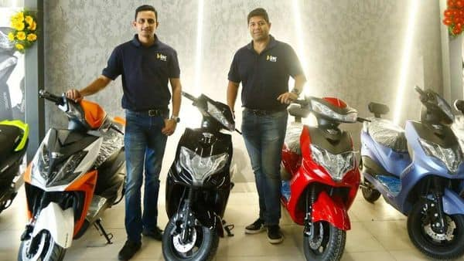

* **IMPORTENCE**

Consumer satisfaction is absolutely crucial for any business. It's the difference between a one-time purchase and a loyal customer who keeps coming back. Here's why it matters so much:

Customer Retention: Happy customers are more likely to repurchase from you than unsatisfied ones. Studies show that "totally satisfied" customers buy 3-10 times more frequently than those who are just "somewhat satisfied" [Source: Kazoo]. Keeping existing customers is cheaper than acquiring new ones, so satisfaction translates to solid business growth.

Positive Word-of-Mouth: People trust recommendations from friends and family more than advertising. Satisfied customers are more likely to spread the word about your business through positive reviews and recommendations, which can bring in new customers organically. Research suggests a single unhappy customer might tell 9-15 people about their bad experience, so positive word-of-mouth is even more valuable [Source: Question Pro].

Brand Advocacy: Delighted customers can become true brand advocates. They'll not only buy from you again, but they'll actively promote your products or services to others. This kind of enthusiastic endorsement is priceless.

* **FACTORS**

There are many factors that affect consumer satisfaction, but some of the most important include:

**Product or service quality**: This is perhaps the most important factor of all. If a customer receives a product that is defective or a service that is poorly performed, they are unlikely to be satisfied.

**Value for money**: Customers want to feel like they are getting a good deal for their money. This means that the price of a product or service should be commensurate with its quality.

**Customer service**: The way that a company treats its customers can have a big impact on their satisfaction. Customers want to feel like they are valued and that their concerns are important.

**Convenience**: Customers want to be able to do business with a company easily and conveniently. This includes things like having a user-friendly website, offering a variety of payment options, and having convenient store hours.

**2.2 LITERATURE REVIEW**

Khan et. al. (2018) The following observations were found on Customer Satisfaction: 1) Linearity exists between endogenous and exogenous variables, correlation means (Sid values) were close to 0.0002) Std. Adjusted R2 value was 0.100 (must be >50%), hence it was a very good model. 3) F-test results of Linear-Regression were F-14.247, p=0.000. Hence it was a good model (not a bad model). At least one exogenous variable was relevant and contributing, to be a good model. 4) Sig. values were nearer to 0.000 in CSR of the brand (0.012), and Safety features (0.024) reveals impact exists; whereas Heritage Design (Antique) preference (0.054), Technology Development (0.262) and Joint Venture Preference (0.611)

Thomson et al. (2020) In a developing country like India, a two wheeler is still a utilitarian product for majority of the customers. This study was conducted to find out what features: drive customer satisfaction in two wheeler market and whether segment-wise differences exist in factors driving customer satisfaction. Data have been gathered from two hundred customers of a popular brand of two wheeler, using a structured questionnaire from Gon, India. Factor analysis revealed that three dimensions existed among features namely ease of use, maintenance and economy. Further regression analysis revealed that for the entire sample as a whole, economy was the only factor driving satisfaction. To test the moderation effect of income, sample was divided into low and high income and separate regression analyses were performed. [4]

Dr. M. Manoher et. al. (2019) This study is based on the market potential of Baja j Auto Ltd in Tirunelveli district, Tamilnadu. The researcher has selected Bajaj Auto Ltd. Bajaj Auto Ltd produced wide range of two wheelers. The researcher has considered three segments of vehicles namely entry segment, executive segment and the premium segment. One vehicle

Charles J. Victor et. al. (2016) The automobile sector is a key performer in the global and Indian economy. The automotive industry. The automotive industry in India is one of the largest in the world and one of the fastest global. Hence, it is concluded that in order to fulfil the expectations of the respondents a proper market survey should be concluded to ascertain their needs and expectations, and accordingly they sould be fulfilled to satisfy the customers and entice this lot to buy e-segment cars. [8]

K. B. Kishan et. al. (2021) It is essential for the royal Enfield to grasp the client preference, to grasp needs the wants the necessities of the clients the purchasers the shoppers and create several modifications in step with the client requirements and convey satisfaction to the customer. This study helps Royal Enfield to grasp the client preference and satisfaction towards the bike. [10]

**3.1 STATEMENT OF PROBLEM**

**Customer Awareness:**

Lack of brand awareness in the electric two-wheeler market.

Potential customers might not be aware of Blive EV or their product range.

**Sales Process:**

Ineffective sales staff who lack knowledge about electric two wheeler s and their benefits.

Unclear or lengthy sales process discouraging customers.

**Product Availability:**

Limited stock of popular models leading to lost sales opportunities.

Long waiting times for deliveries.

**Test Ride Experience:**

Difficulty in offering test rides due to limited space or staff availability.

Unimpressive test ride experience not showcasing the full potential of the vehicles.

**After-Sales Service:**

Concerns about after-sales service network and availability of spare parts.

Long wait times for repairs or maintenance.

**3.2 NEED FOR THE STUDY**

Studying the establishment of an EV electric two-wheeler showroom is crucial for several reasons:

**Understand Customer Satisfaction:** Learn how satisfied customers are with electric vehicles at Belive store in Jalgaon to improve their experience.

**Identify Improvement Areas:** Pinpoint areas where electric vehicles can be enhanced to meet customer needs and preferences better.

**Support Market Growth:** Gather insights to support the growth of the electric vehicle market in Jalgaon and beyond.

**Promote Sustainable Transportation:** Encourage the adoption of eco-friendly transportation options by addressing customer concerns and preferences.

**Tailor Offerings:** Use feedback from customers to customize electric vehicle offerings at the Belive store to better match local demand and preferences.

**3.3 OBJECTIVES OF THE STUDY**

Customer preferences: Understand the preferences of potential customers for electric 2-wheelers. This could involve factors like desired range, price point, features, and brand perception.

Market competition: Analyze Blive's position in the electric 2-wheeler market compared to competitors. This might include factors like product offerings, pricing strategy, and showroom experience.

Growth potential: Assess the potential for growth in the electric 2-wheeler market in the region served by the showroom.

Customer experience: Evaluate the customer experience at the Blive EV showroom. This could involve factors like sales staff knowledge, test ride availability, and overall showroom layout and ambience.

Sales effectiveness: Analyze the effectiveness of the showroom's sales process in converting leads into customers.

Marketing effectiveness: Assess the effectiveness of the showroom's marketing efforts in attracting potential customers.

**3.4 RESEARCH METHODOLOGGY**

Research is the arrangement structures with strategies for investigation conceived for answers to researched questionnaires with controlled be composed since which basis by on top of reveal information in the primary data and secondary data.

**METHODOLOGGY STUCTURE AND RESEARCH**

**Research Region:** jalgaon

**Research Approach:**

**Sampling procedure:** Random sample

**Contact technique:** Personal

**Sample Component:** users of blive ev stotre

**Research Instruments:** Questionnaires

**Sample size:** 100

**RESEARCH DESIGN**

The lessons commence to way in the following deal service and customer's satisfaction in the direction of blive ev store ltd. Jalgaon

**RESEARCH PROCEDURE:**

The questions are arranged for the studies in the structure and disguise within nature. It consists of various choice and short question.

**DATA**:

Information's which, through the facilitating of questionnaire system with convention diverse electric vehicled possessor blive ev store pvt ltd. The data has collected from more than 50 customers, in the topic of basic random sampling

Secondary data is composed form the company annual-reports, journal, publication, and websites etc.

**SAMPLE DESIGN:**

The sample unit confined to ending consumer of products i.e., blive ev store ltd. Owners knows their satisfaction levels based on performances of electric vehicle and services.

**SAMPLE UNIVERSE:**

The assessment was done in Blive EV Store, according to my convenience it is not gives the exact result of Maharashtra or India.

**PERIOD OF STUDY:**

Study is done during the year 2023

**SAMPLE PROCEDURE:**

The sample-size is 100 consumers only. The illustration consists of Businessman, Doctors, Engineers, Officers and Contractors etc. The analysis was analyse in-form a consultation surrounded by accidentally special sample of more than 50 regulars of Blive ev store ltd customer's model amount form the trader casual.

**ANALYTICAL METHOD:**

Basic percentages methods have to use for identifying purpose

**DESCRIPTIVE STUDIES:**In descriptive studies, when a research person is awareness to knows the character of certain grouping as era, sex, educational levels, employment of incomes, the expressive revise is necessary. Descriptive study is well structure. therefore, it necessary that pollster objectives of a study to answer under investigation

**3.5LIMITATIONS OF THE STUDY**

**Sample Bias:** If the study only involves customers who have visited the showroom, it may not capture the perspectives of potential customers who chose not to visit or those from different demographics.

**Time Constraints:** The study may not reflect long-term trends or changes in consumer behavior due to the limited duration of data collection.

**Lack of Control Group:** Without a comparison group, it may be challenging to attribute observed effects solely to the showroom experience, as other factors could also influence customers' perceptions and behaviors.

**Self-Selection Bias:** Customers who choose to visit the showroom may already have a positive predisposition towards electric vehicles, leading to skewed results regarding satisfaction and purchase intent.

**Data Quality:** Issues such as incomplete or inaccurate responses in surveys, or inconsistencies in data collection methods, could affect the reliability and validity of the findings.

**4. DATA ANALYSIS AND INTERPRETATION**

Under this section of the project, questionnaire circulated is thoroughly analyse and interpreted, based on which suggestions and recommendations will be given which would help hero in strengthening their customer base.

All questions asked are analyzed below and graphically represented and each question and response are analyzed and results interpreted.

This section of the project holds immense importance as in, it depicts the level of customer satisfaction towards the blive product.

All questions asked in the questionnaire are analyzed and the interpretation are drawn below

**SURVAY QUESTIONS**

1. **WHERE DID YOU GET THE IDEA TO BUY AN ELECTRIC VEHICLE ?**

|  |  |
| --- | --- |
| **PARTICULARS** | **PERCENTAGE** |
| NEWS PEPAR | 20.9% |
| TV ADVERTISEMENT | 26.9% |
| FRIENDS | 38.8% |
| OTHER | 13.4% |
| **TOTAL** | **100** |

**INTERPRETATION:**Above information shows where the customer got information about electric vehicle news pepar 20.9%, tv ads 26.9%, friends 38.8% and other13.4%.

**2] WHERE DID YOU GET THE INFORMATION ABOUT BLIVE EV STORE ?**

|  |  |
| --- | --- |
| **PARTICULARS** | **PERCENTAGE** |
| NEWS PEPAR | **41.8%** |
| FRIENDS | **34.3%** |
| OTHER | **23.9** |
| **TOTAL** | **100%** |

**INTERPRETATION:**The above information shows how the customer knows about blive ev store news pepar 41.8%, friend 34.3%, and other 23.9%.

**3] FOR WHAT PURPOSE TO BUY ELECTRIC VEHICLE ?**

|  |  |
| --- | --- |
| **PERCENTAGE** | **PERCENTAGE** |
| OFFICIAL | **37.9%** |
| BUSINESS | **17.9%** |
| HOUSEHOLD | **23.9%** |
| OTHER | **20.9%** |
| **TOTAL** | **100%** |

**INTERPRETATION:**The above information shows, the intention of consumers to purchase an electric vehicle, is official 37.9%, business 17.9%, household 23.9% and other 20.9%.

**4] WHICH QUALITY OF THE ELECTRIC VEHICLE ATTRACTS YOU MOST ?**

|  |  |
| --- | --- |
| **PARTICULARS** | **PERCENTAGE** |
| DESIGN | **23.9%** |
| PRICE | **22.4%** |
| LOW MAINTENANCE | **26.9%** |
| CHARGINDG COST | **26.9%** |
| **TOTAL** | **100%** |

**INTERPRETATION:**Above information shows, why customer like electric vehicle,Design 23.9%, Price 22.4%, Low maintenance26.9% and charging cost 26.9%.

**5] HOW WOULD YOU RATE THE FOLLOWING SERVICE OF BLIVE EV STORE ?**

|  |  |
| --- | --- |
| **PARTICULARS** | **PERCENTAGES** |
| COMPLETELY SATISFIED | 23.9% |
| SATISFIED | 52.2% |
| FAIR | 20.9% |
| DISSATISFIED | 3% |
| **TOTAL** | 100% |

**INTERPRETATION:**The above information shows how blive ev store customers rate the services, 23.9% is completely satisfied, satisfied 52.2%, fair 20.9% and satisfied 3%

**6].HOW WAS THE COOPERATION OF THE STAFF DURING SERVICES?**

|  |  |
| --- | --- |
| **PARTICULARS** | **PERCENTAGES** |
| EXCELLENT | **23.9%** |
| GOOD | **58.2%** |
| FAIR | **13.4%** |
| BAD | **4.5%** |
| **TOTAL** | **100%** |

**INTERPRETATION:**The above information shows that how the employees behave during the service is very good 23.9%, good 58.2%, fair 13.4% and bad 4.5%.

**7] WHICH TYPE OF EV YOU HAVE ?**

|  |  |
| --- | --- |
| **PARTICULARS** | **PERCENTAGE** |
| ELECTRIC SCOOTER | **46.3%** |
| ELECTRIC BIKE | **32.8%** |
| ELECTRIC CYCLE | **6%** |
| OTHER | **14.9%** |
| **TOTAL** | **100%** |

**INTERPRETATION:**The above information shows that which ev the consumer owns is electric scooter 46.3%, electric bike 32.8%, electric cycle 6% and others 14.9%.

**8] WHAT SHOULD BE THE RANGE OF YOUR ELECTRIC VEHICLE WHEN FULLY CHARGED?**

|  |  |
| --- | --- |
| **PARTICULARS** | **PERCENTAGE** |
| 50 TO 80 | **19.4%** |
| 80 TO 100 | **46.3%** |
| 100 TO 150 | **19.4%** |
| 150 TO 200 OR MORE | **14.9%** |
| **TOTAL** | **100%** |

**INTERPRETATION**:The above data shows that the average mileage of a customer's EV after full charge is 50 to 80 19.4%, 80 to 100 46.3%, 100 to 150 19.4%and 150 to 200 and more14.9%.

**9].WHERE WOULD PREFER TO CHARGE YOUR ELECTRIC VEHICLE?**

|  |  |
| --- | --- |
| **PARTICULARS** | **PERCENTAGE** |
| AT HOME | 58.2% |
| AT OFFICE | 20.9% |
| USING PUBLIC CHARGING FACILITIES | 20.9% |
| **TOTAL** | 100% |

**INTERPRETATION:**According to the above data, where the consumer charges his EV is, at home 58.2%, office 20.%9 and using public charging facilities 20.9%.

**10].IN FUTURE CAN ELECTRIC VEHICLE CAN FULLY REPLACE PETROL VEHICLE?**

|  |  |
| --- | --- |
| **PARTICULRS** | **PERCENTAGE** |
| YES | **37.3%** |
| NO | **22.4%** |
| MAY BE YES | **31.3%** |
| MAY BE NO | **9%** |
| **TOTAL** | **100%** |

**INTERPRETATION:** According to the above information, electric vehicle can completely replace petrol vehicle in future, yes 37.3%, no 22.4%, yes 31.3% and, 9%.

**5.1 SUMMARY OF FINDINGS:**

**Range:** Blive EV offers a variety of electric two-wheeler s with different ranges to suit various needs and preferences.

**Models:** The showroom likely showcases a range of models, including scooters, motorcycles, and possibly electric bicycles.

**Features:** Each model is equipped with different features such as battery capacity, charging time, top speed, and smart connectivity options.

**Price Range:** The showroom provides electric vehicles at different price points to cater to a wide range of customers.

**Warranty and After-sales Service:** Information on warranty periods and after-sales service support would be available for customers.

**Charging Infrastructure:** They may also provide information about charging infrastructure and solutions for customers’ convenience.

**Government Incentives:** Details about government incentives and subsidies for purchasing electric vehicles might also be provided to encourage sales.

**Test Rides:** Customers are likely offered the opportunity to take test rides to experience the performance and features of the electric two wheeler s firsthand.

**5.2 CONCLUSION**

In conclusion, the BLive EV electric two-wheeler showroom offers a dynamic blend of sustainability, innovation, and convenience. With a diverse range of electric vehicles, cutting-edge technology, and exceptional customer service, it provides an unparalleled experience for Eco-conscious consumers seeking reliable and stylish transportation solutions. BLive EV is not just a showroom but a gateway to a greener future on two wheels.

BLive isn't exactly a showroom for a single brand of electric vehicles. Instead, it functions as a multi-brand EV experience store. This means they offer a variety of electric two-wheeler s from various manufacturers under one roof.

Here's what you can expect at a BLive EV showroom:

**See and explore:** electric scooters and bikes from various brands.

**Compare features and specifications:** of different models to find the best fit for you.

**Get expert advice:** from BLive's staff to help you choose the right EV.

**Potentially purchase:** an electric two-wheeler directly from the showroom.

BLive aims to be a one-stop shop for all your electric vehicle needs.

**6. SUGGESTIONS AND RECOMMENDATIONS:**

**Analyze any recurring themes:** Look for areas where there might be room for improvement, even if satisfaction is generally high. This could be wait times, limited inventory of a popular model, or lack of clarity on financing options.

**Address negative feedback:** If there were any negative comments, develop an action plan to address those concerns. This shows you take customer feedback seriously.

Additional Recommendations:

**Promote a welcoming environment:** Ensure the showroom is clean, well-organized, and has comfortable seating for customers.

**Train staff to be knowledgeable:** Staff should be able to answer questions about different EV models, charging options, government incentives, and servicing.

**Offer test rides:** Allow potential customers to experience the EVs firsthand.

**Provide clear information:** Display pricing, specifications, and financing options prominently.

**Utilize digital tools:** Offer online appointment scheduling, virtual tours, and online chat support for customer convenience.

**Maintain a strong online presence:** Ensure the Blive website and social media channels are up-to-date with product information, promotions, and customer reviews.

**BIBILOGRAPHY**

**BOOKS:**

* **Principles of Marketing - Philip Koestler & Gary Armstrong**
* **Marketing Research - G. C. Brie**
* **Services Marketing - Adrian Palmer**

**ARTICLES:**

* **The Financial Express**
* **ET Auto**
* **The Hindu Business Line**
* **THE Auto Motive India**
* **Wheel city**

**WEBLIOGRAPHY**

* [**www.bliveecstore.com**](http://www.bliveecstore.com)
* [**www.financialexpress.com**](http://www.financialexpress.com)
* [**www.autofinlimited.com**](http://www.autofinlimited.com)
* [**www.wikipedia.com**](http://www.wikipedia.com)
* [**www.google.com**](http://www.google.com)

**ANNEXURES**

**QUESTIONNAIRE**

Dear Sir,

I am HARSHAL SURESH SONAWANE student of MBA, KCE'S INSTITUTE OF MANAGEMENT AND RESEARCH, JALGAON, conducting a survey on Customer Satisfaction towards Blive EV STORE Ltd.

Please give your precious feedback regarding Blive EV STORE Ltd.

Name:

Address:

1. **WHERE DID YOU GET THE IDEA TO BUY AN ELECTRIC VEHICLE ?**
2. **NEWS PEPAR**
3. **TV ADVERTISEMENT**
4. **FRIENDS**
5. **OTHER**
6. **WHERE DID YOU GET THE INFORMATION ABOUT BLIVE EV STORE ?**
7. **NEWS PEPAR**
8. **TV ADVERTISEMENT**
9. **OTHER**

**3]FOR WHAT PURPOSE TO BUY ELECTRIC VEHICLE ?**

1. **OFFICIAL**
2. **BUSINESS**
3. **HOUSEHOLD**

**D.OTHER**

**4] WHICH QUALITY OF THE ELECTRIC VEHICLE ATTRACTS YOU MOST ?**

**A. DESIGN**

**B. PRICE**

**C. LOW MAINTANANCE**

**D. CHARGING COST**

1. **HOW WOULD YOU RATE THE FOLLOWING SERVICE OF BLIVE EV STORE ?**
2. **COMLETELLY SATISFIED**
3. **SATISFIED**
4. **FAIR**
5. **DISSATISFIED**

**6] HOW WAS THE COOPERATION OF THE STAFF DURING SERVICES?**

1. **EXCELLENT**
2. **GOOD**
3. **FAIR**
4. **BAD**

**7] WHICH TYPE OF EV YOU HAVE ?**

1. **ELECTRIC SCOOTER**
2. **ELECTRIC BIKE**
3. **ELECTRIC CYCLE**
4. **OTHER**

**8] WHAT SHOULD BE THE RANGE OF YOUR ELECTRIC VEHICLE WHEN FULLY CHARGED?**

1. **50 TO 80**
2. **80 TO 100**
3. **100 TO 150**
4. **150 TO 200 OR MORE**

**9] WHERE WOULD PREFER TO CHARGE YOUR ELECTRIC VEHICLE?**

1. **AT HOME**
2. **AT OFFICE**
3. **USING PUBLIC CHARGING FACILITIES**

**10] IN FUTURE CAN ELECTRIC VEHICLE CAN FULLY REPLACE PETROL VEHICLE?**

1. **YES**
2. **NO**
3. **MAY BE YES**
4. **MAY BE NO**